EXPERIMENT-1 ADDITION

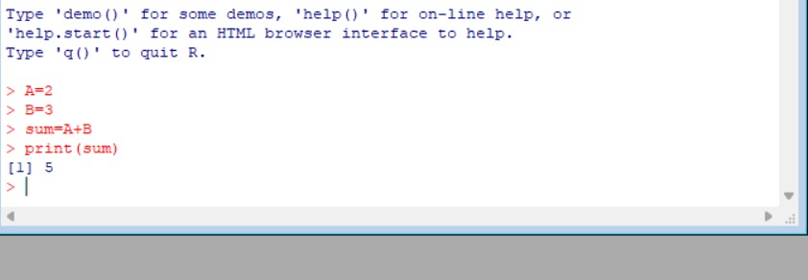

EXPERIMENT-2 SUBTRACTION

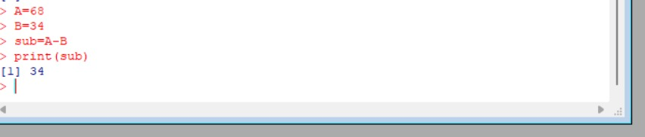

EXPERIMENT-3 MULTIPLICATION

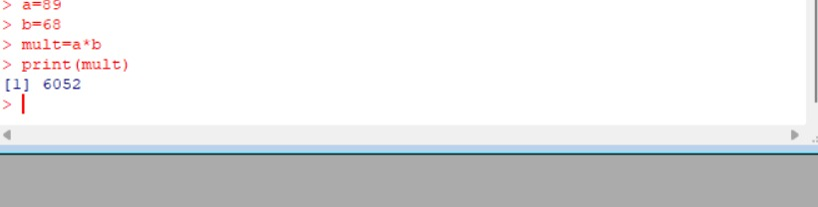

EXPERIMENT-4 DIVISION:

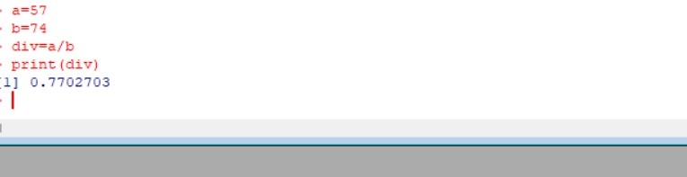

EXPERIMENT-5 ODD OR EVEN
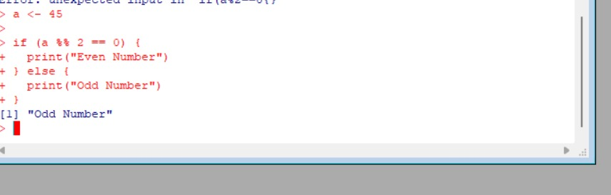

EXPERIMENT-6 MEAN,MEDIAN,MODE:
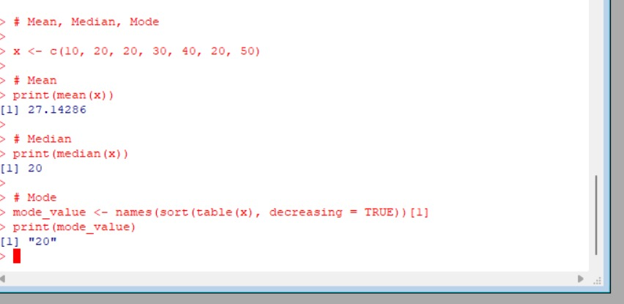

EXPERIMENT-7 SUMMARY:

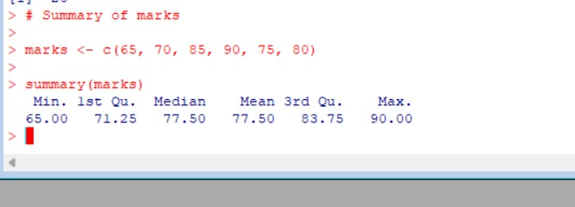

EXPERIMENT-8 GREATER AMONG THREE NUMBERS:
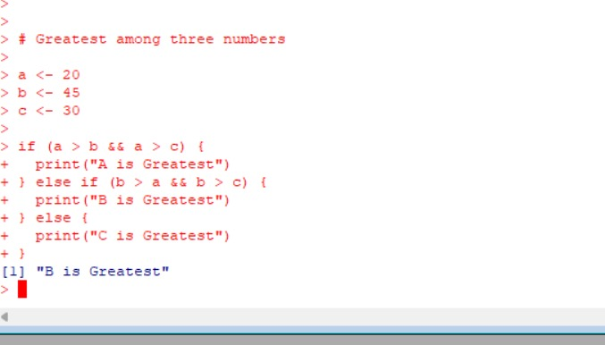

EXPERIMENT-9 IQR:
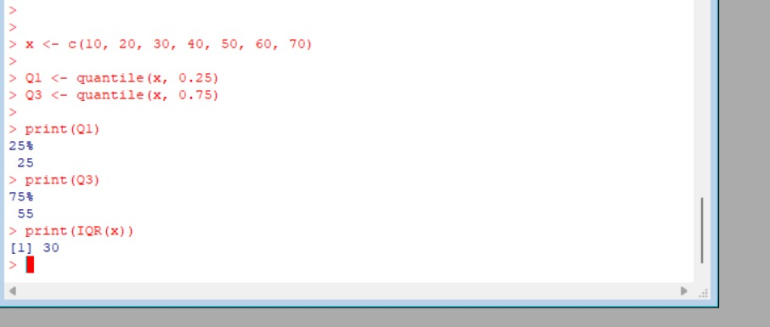

EXPERIMENT-10 QUANTILE:
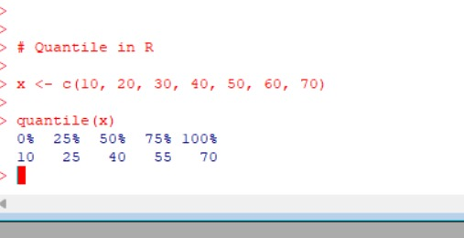

EXPERIMENT-11 MID RANGE:

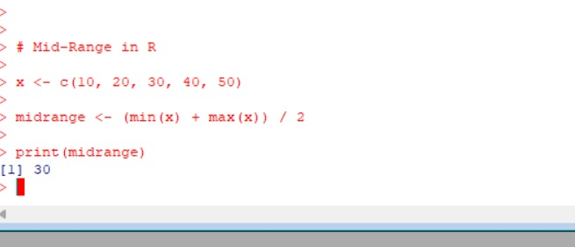

Z-SCOORE NORMALIZATION:
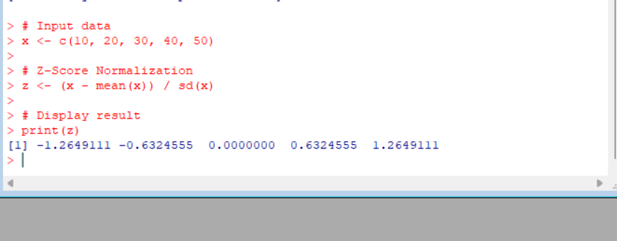

EXPERIMENT-13 MIN,MAX,MEAN,MINMAX:

